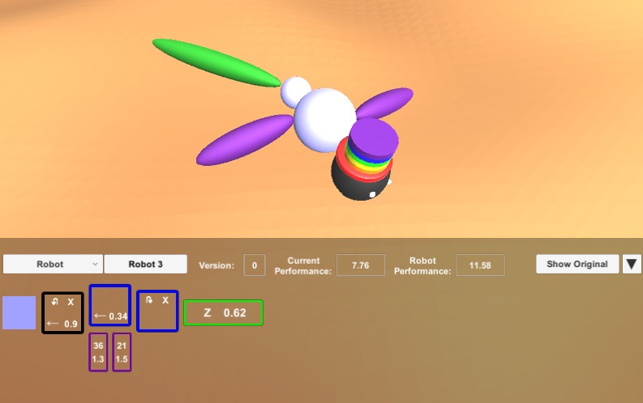

Line thickness = mass

Size = size

Position offset = joint constraint

Drive velocity

Gait multiplier

Is driving

Angle offset

Is rotating (left for sin, right for cos)

Mass multiplier

Primary axis of rotation

Body colour

Select view option

Select robot

Current version

Current performance

Overall performance

Toggle between current robot / its original form

Collapse UI

Robot 3 is given a rainbow top hat to stand out from the crowd

**6**

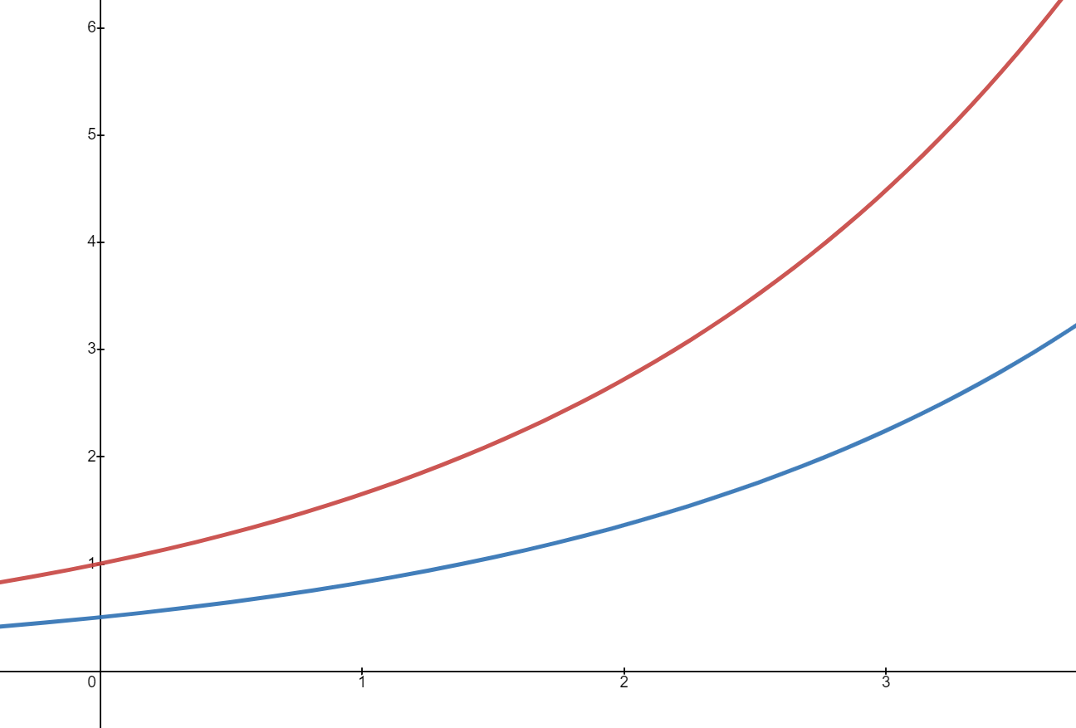

**Attempt (x)**

**1**

**5**

**4**

**2**

**3**

**3**

**2**

**1**

$$y={ae}^{\frac{x}{2}},$$

$$a=0.5$$

$$y={ae}^{\frac{x}{2}},$$

$$a=1$$

**Activation**

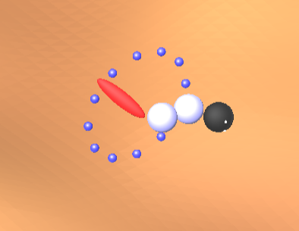

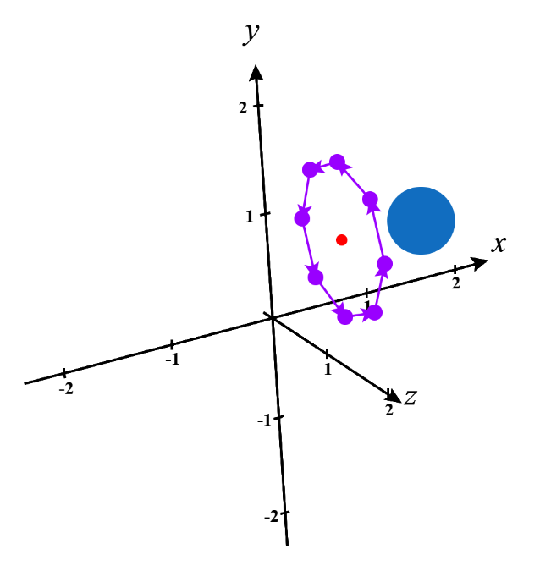

Body

**α**

Angle Offset

Leg Velocity

Axis of rotation